Unit Group Project 2 – Code Explanation

Oscar Garcia, Ethan Carter, Antz Claveus, Thomas Lilchin
Department of Engineering and Technology, Miami Dade College
COP 2800: Java Programming
April 5, 2026

In the Unit Group Project 2, we went over several concepts including loops, conditionals, method calling, and validation. As we created this console-based program, we went through several hurdles that we would like to reflect upon.
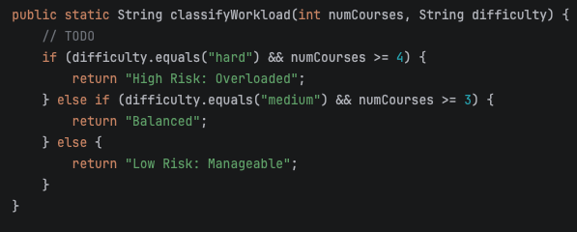
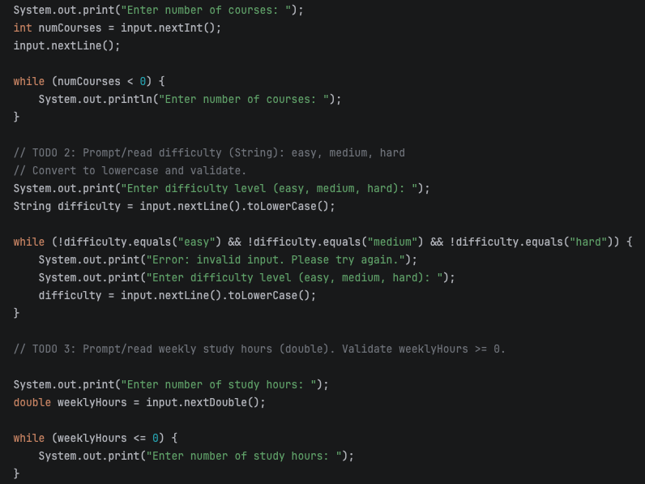
First off, we want to talk about our use of decision structure. Though we had the option of using a switch statement, we felt that it was not the appropriate decision structure as we were not dealing with a menu-based application. In our case, if-else statements felt more appropriate as we were just prompting and manipulating/handling data input by the user. If-else statements were used in the classifyWorkload method. And while loops were used in lines 31, 42, and 53 respectively.
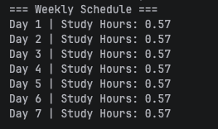
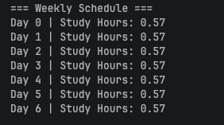
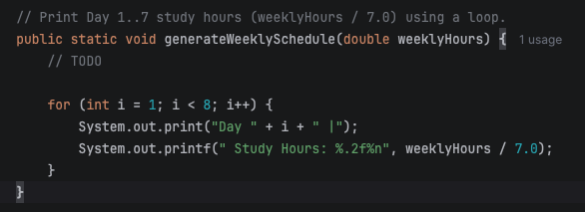
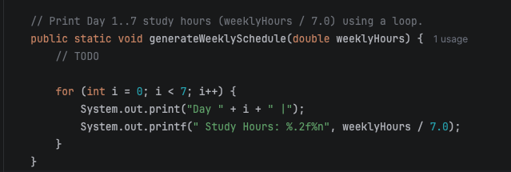

Next up, we would like to reflect on any “off-by-one” or boundary issues that we encountered in our conditions. One issue that we stumbled upon was in the use of our for-loop which was implemented in our generateWeeklySchedule method. The issue that we stumbled upon was our day count being “off-by-one”. For example, the program would output: “Day 0… Day 6”. Oscar caught that we were using int i = 0 rather than i = 1 and i < 6 instead of i < 7.
Next, let’s touch on the loops that we used in our program. While are choices were for, while, and do-while loops, we preferred to use for and while loops as it just felt more natural to use rather than using a do-while loop. Additionally, we didn’t find a need to use a loop like a do-while loop that is guaranteed to run at least once.
Next up, let’s look at what we did to prevent user input from breaking our program. To do this, we utilized three while loops (pictured in the previous page) in lines 31, 42, and 53. In the first of these while loops, we checked if numCourses was less than 0, and if it is, we prompt the user to re-enter the number of courses. Next, for the while loop on line 42, we validated if the user entered anything other than “easy”, “medium”, or “hard”. We did this by using the .equals operator and checking for is “easy” AND is “medium” AND is “hard”. We did this to avoid having the user enter something other than a valid difficulty level and still processing all the data with that incorrect difficulty level. Finally, for the while-loop on line 53, we validated if weeklyHours was less than or equal to 0. This was done to avoid the user entering negative or zero weeklyHours, which would be impractical for the use this weeklyHours variable entails.
Next up, let’s look at how decisions and loops together improved the usefulness of our advisor. By utilizing loops in our program, we made sure that incorrect data was not passed to our methods. This was done via input validation in the areas of numCourses, difficulty, and weeklyHours. Additionally, we used a for-loop in generateWeeklySchedule that prints out the weekly schedule in a neat and orderly fashion. All these things helped make our program useful, whereas not implementing these concepts into our program would have resulted in a bug-ridden, quite frankly, useless program as the user could input a negative number of courses, a string other than the valid difficulty levels, and a negative or invalid number of weeklyHours.
The hardest loop logic fix was the use of input.nextLine() because of certain scenarios where it’s supposed to be only “Enter difficulty” but then the whole prompt for “Error” shows up right after without further input.
When it comes to scalability in terms of adding more difficulties and days, the design wouldn’t change much, but rather just be a longer list.
The indentation and proper spacings for the if & else if statements helped in understanding nested logic better because it shows very clearly which category of difficulty the user input and depending on the numCourses & difficulty that matches the condition, will return with high, balanced or low risk. After getting all that checked out, I tested about 4 different input combinations and from what I learned is that when inputting numbers such as 0 or anything below that results in “Enter number of courses” to re-prompt until given a valid input of 1 or higher and loops are really good for not only validating, but can also be used for repeating a prompt until valid.
As to where I can see real world applications where decisions and loops work together is digital shopping apps like Amazon where the loop goes through a validation check of all items in cart and decisions would check for stuff like eligibility in shipping and available discounts.

